Ex1: Implementation of Toy problem using Python

RA1911028010074

Aayush Singh

06/01/2022

Question: A person has 3000 bananas and a camel. The person wants to transport the maximum number of bananas to a destination which is 1000 KMs away, using only the camel as a mode of transportation. The camel cannot carry more than 1000 bananas at a time and eats a banana every km it travels. What is the maximum number of bananas that can be transferred to the destination using only camel (no other mode of transportation is allowed)

Approach: There would be one or more than one checkpoint. We are breaking each section of the checkpoint in the sections of length one.  
Here transportation is done in 1-mile steps. As in the example discussed above, camel walks with 1000 bananas for 1 mile left 998 bananas there and consume 2. In the last round, the camel will consume only one banana.  
At each subsequent mile, we are subtracting the no. of bananas lost in travelling each mile from the total no. of bananas. To calculate the total bananas left after 1 mile we use another variable start.

Code:

total=int**(**input**(**'Enter no. of bananas at starting'**))**

distance=int**(**input**(**'Enter distance you want to cover'**))**

load_capacity=int**(**input**(**'Enter max load capacity of your camel'**))**

lose=0

start=total

for i in range**(**distance**)**:

while start**>**0:

start=start-load_capacity

if start==1:

lose=lose-1.

lose=lose+2

lose=lose-1

start=total-lose

if start==0

break

print**(**start**)**

Output:

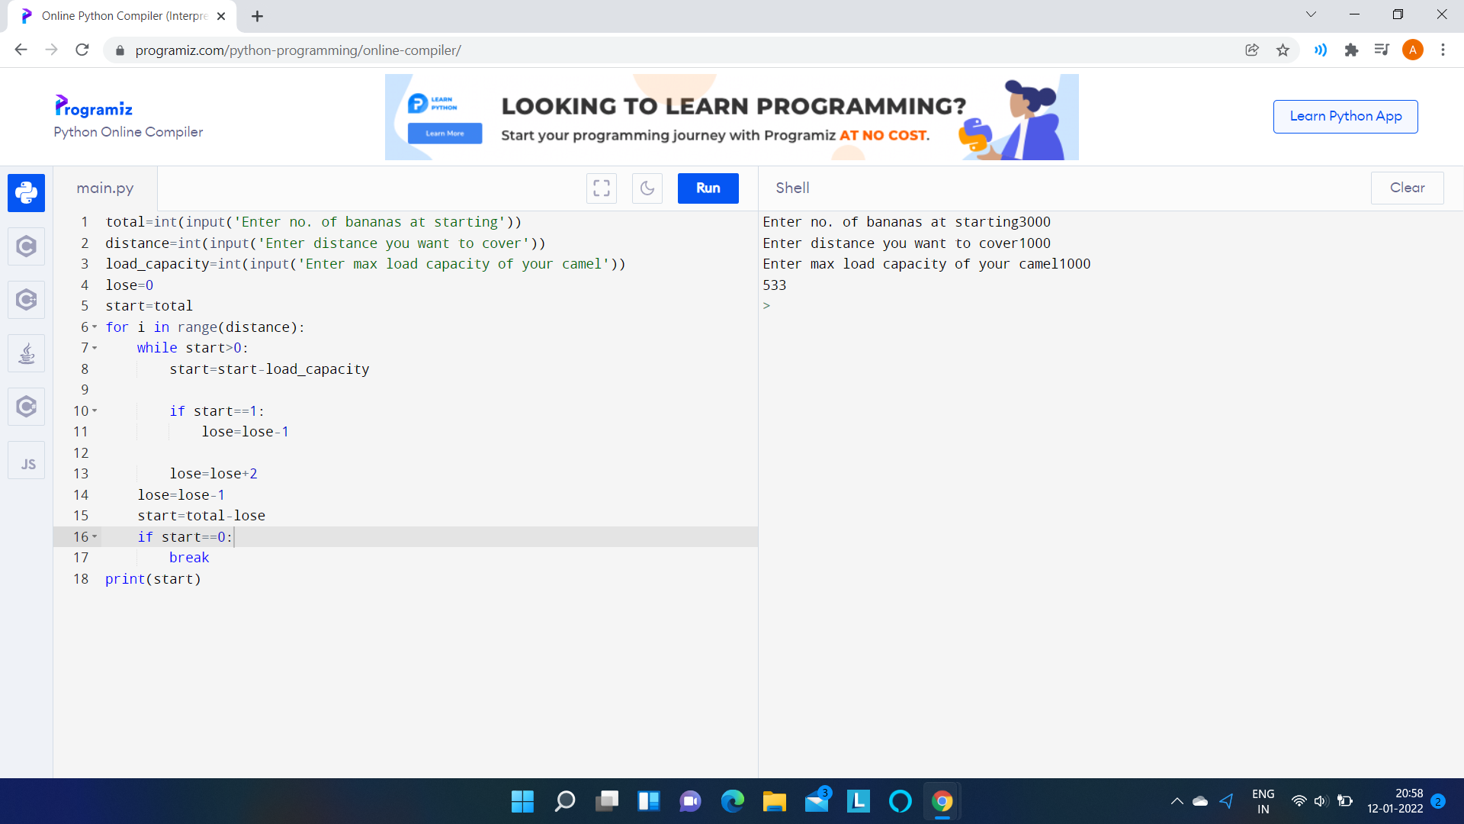

Result: Hence a toy problem was successfully executed and the output has been verified.